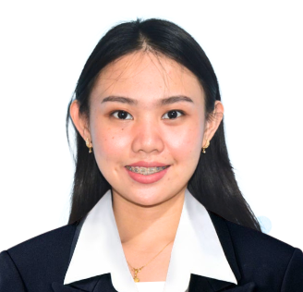
Bio Data Sheet

Name of Student: Gwyneth Lei Thongratnachat Manaois_________________
University Name: Pangasinan State University Bayambang Campus_______
University Address: Zone 6 M.L Quezon Boulevard Bayambang, Pangasinan
Philippines________________________________________________________
Faculty: Science and Mathematics Department __Major: Science Major____
Year of Study (3rd or 4th): Fourth Year Preferred level to teach: Grade 8__
Preferred Subject to Teach: BIOLOGY_________________________________________________
Home Address: #38 Sitio Dela Cruz Pamaranum Malasiqui, Pangasinan______________________
Email Address: gwynethmanaois@gmail.com_____________________________________________
Mobile No.: 09934583306______________________________________________________________
Emergency Contact: (please provide 2 persons)
- Name: Julie Ann T. Manaois __________________ _Relationship: Mother_______________
Mobile No.: 09065589869
- Name: Christopher R. Manaois __________________ Relationship: Father______________
Mobile No.: 09934583306

Personal Information
Date of Birth (DD/MM/YYYY): 02/16/2003________________________________________________
Age: 22____________________________Gender: Female _________________Blood Type: A+_____
Drug Allergy: None____________________________________________________________________
Nationality: Filipino______________________________ Ethnicity: Asian_______________________
Religion: Roman Catholic _________________________________Marital Status: Single__________

Educational Background:
- 2021 – Present
Pangasinan State University Bayambang Campus
Bachelor of Secondary Education Major in Science
  - President’s List (Third Year, Second Sem)
  - Dean’s List (First Year – Third Year)
- 2019 – 2021
Pangasinan State University Laboratory High School
With Honors
- 2015 – 2018
Perpetual Help College of Pangasinan
With Honors
- 2008 – 2014
Palapar Elementary School
Class Valedictorian
Experiences:
SEMINARS, TRAININGS, AND EXPERIENCES
Training-Workshop on Building Future-Ready STEM Classrooms with Transformative Strategies
- Gained insights into innovative teaching strategies to create engaging and future-ready STEM learning environments.
School Learning in Action Cell in Science Department (March 20, 2024)
- Participated in collaborative discussions and workshops to enhance teaching methodologies and foster professional growth in science education.
English as a Second Language (ESL) Tutor at ACADSOC (July 2021 – September 2021)

- Assisted non-native English speakers in improving their language skills through personalized one-on-one tutoring sessions.
Language Skills:
English: Fluent (Written and Spoken)

- Proficient in academic and conversational English.

Experience as an ESL tutor, demonstrating strong communication and teaching skills.

Filipino (Tagalog): Native Proficiency

- Fluent in speaking, reading, and writing.

Basic Indonesian (Bahasa Indonesia): Beginner

- Currently learning basic phrases and conversational skills to better adapt to Indonesian culture and daily interactions.

- Enthusiastic about improving my Bahasa Indonesia skills during my exchange program.

